## Display Engine

### 1.1 Overview

Display controller defines a high-performance optimized-area display core that can be used for reading rendered images from the frame buffer to the display. In addition to providing hardware cursor patterns, the display controller performs format conversions, dithering and gamma corrections. This controller includes support for parallel pixel output and is easily adapted to external serialization logic, for example HDMI.

### 1.2 Block Diagram

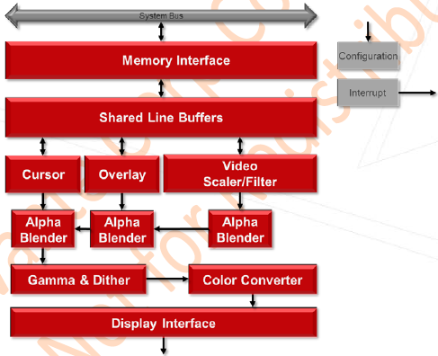

Fig. 1.1 Display controller module block diagram

Following are various modules in the Display Controller:

* **Host Interface**

Allows the core to communicate with external memory and the CPU through the AXI and AHB buses.

* **Front End and Pixel Pipeline**

Single display pipeline supports linear frame buffers for RGB and YUV inputs.

* **Cursor**

Provides hardware cursor functionality

* **Dither**

Provides and indexable look-up-table for dither function

* **Gamma Correction**

Provides a gamma correction SRAM for its function

* **Display Interface**

Supports Parallel Pixel Output with 24-bit Data, Hsync, Vsync, Data enable. Enable adapted to external serialization logic, e.g. HDMI.

### 1.3 Features

* Video Timing Generation
* HSYNC, VSYNC, DE signals
* Programmable timers
* Display Interface
* Parallel Pixel Output with 24-bit Data, HSync, VSync, Data enable
* DPI 24-bit, 18-bit(2 configs) and 16-bit(3 configs) support
* Easily adaptable to external serialization logic, e.g. HDMI.
* Display
* Single display
* Maximum display size: 4Kx2K
* Sync and bland signals
* Gamma and dither tables
* Input Formats
* ARGB2101010,A/XRGB8888,A/XRGB1555,RGB565,A/XRGB4444
* Index1/2/4/8
* YUV422 packed & semi planar (YUY2, UYVY, NV16)
* YUV420 semi-planar (P10), NV12 and YUV420 semi-planar (10bit, 1 pixels 2 bytes)
* NV12 (10bit, 3 pixels 4 bytes) and NV16 (10bit, 3 pixels 4 bytes) for overlay only
* Format Conversion
* Pixel inputs accepted from multiple RGB and YUV formats
* Color Space Conversion BT.2020 and BT.709
* Pixel output is 24bit RGB in multiple formats
* Output Formats
* ARGB2101010/DPI_D16CFG1/DPI_D16CFG2/DPI_D16CFG3/DPI_D18CFG1/DPI_D18CFG2/DPI_D24/DPI_D30
* Hardware Cursor
* Supports ARGB88 and Mask cursor formats
* Color
* A separate Look Up Table for Dither
* A separate Look Up Table for Gamma Correction
* Overlay with coordinate generator
* Alpha Blending
* Filter and Scaling
* Vertical and horizontal scaling
* Horizontal 3/5 tap; vertical 3 tap
* Programmable filter order
* 15.16 fixed point scaling factor